**NAME :**  SOWNDARYA V

**DEPARTMENT :** INDUSTRIAL BIOTECHNOLOGY

**COLLEGE :** GOVERNMENT COLLEGE OF TECHNOLOGY,COIMBATORE.

**NAAN MUDHALVAN**

**COURSE :** DIGITAL MARKETING

**NAAN MUDHALVAN**

**ID :** 3546EC3B819124997F145B861D0D63B3

**ASSIGNMENT ON DIGITAL MARKETING**

1. Create a blog or website using blogspot and wordpress.Customize

the theme design and post new article with 500 words.

Blogspot:

<https://flims55.wordpress.com/2023/10/30/indian-films/>

Wordpress:

<https://wordpress.com/home/flims55.wordpress.com>

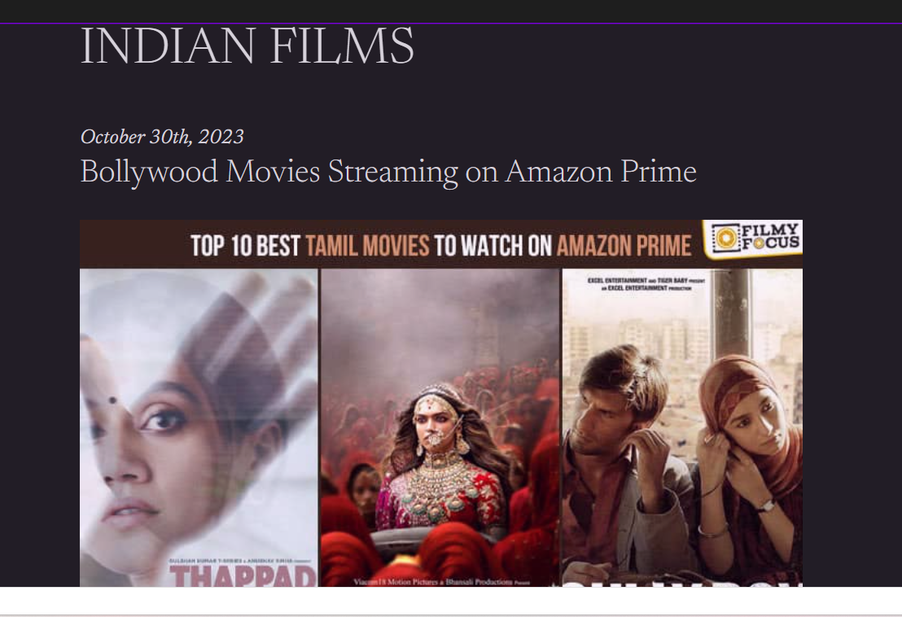

2.Create a new facebook business page and post one social media poster for your brand.

<https://www.facebook.com/61552684691104/posts/pfbid0Wc2czmLCHwrshtXbuZ5jhCBwfAs6tp5eQSkbtFKWp6ZadDjGr2TwWyehN5ndAzqkl/?app=fbl>

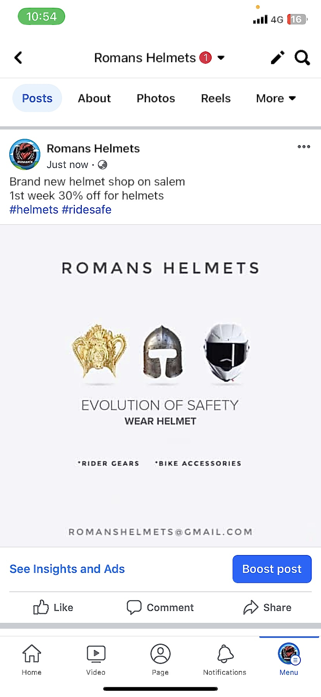

3.Create and design a social media advertisement poster using canva.



4. Create email newsletter design using Mailchimp or canva tool.

